|  |  |
| --- | --- |
| **Name**: Hendy | **Title**: Olympic Performance Analysis Based on Medals |

1. **Objectives**

The Olympic Games are the most anticipated and significant international events. Olympic games are often regarded as a prestigious platform for athletes worldwide to demonstrate their skills and prove themselves as the best in their respective sports.

This project aims to communicate the following messages:

* **Country Performance Trends**: An analysis of medal achievements by country, examining how different nations have performed across Olympic history and highlighting changes in dominance over time.
* **Impact of Gender on Performance**: A comparative analysis of gender-based participation and success rates in both team and individual events, revealing trends and differences in performance outcomes.
* **Influence of Age on Athletic Success**: An exploration of age demographics in Olympic participation, aiming to identify age ranges associated with peak performance and to determine if there is an optimal age for success in various sports.

The objectives of this project are to visualize the country's performance which contains a rich history of information and also analyse some aspects that could affect the impact of gender and age group on athletic success. Gender and age have been selected as focal topics to provide insights into how these factors influence performance outcomes across different sports and event types.

1. **Novelty**

This project incorporates several unique contributions in the realm of Olympic data visualization. Drawing initial inspiration from prior datasets, such as the Paris Olympic data 2024 [1], I expanded the scope significantly by including a comprehensive historical analysis from 1896 through 2022 [2], rather than focusing solely on the most recent games. This broadened dataset allowed for a deeper exploration of trends over time and enabled me to provide insights across a variety of historical contexts.

One of the primary innovations in this project is the use of a choropleth map, a new visualization technique that I implemented to display the total number of participants from each country and the number of those participants who achieved medals. This approach leverages the inherently global nature of the Olympics, allowing viewers to see participation and success rates across nations at a glance. Given the wide representation of countries in the Olympic Games, the dataset offers a comprehensive view of international contributions and achievements, making the choropleth an ideal choice for this analysis.

Furthermore, the design and implementation of this project incorporated several enhancements over initial references, applying new design principles to optimize visual clarity, interactivity, and engagement. By refining these elements, this project aims to offer a distinctive, visually rich perspective on Olympic history and performance that sets it apart from existing visualizations.

1. **Technical Challenges and Innovation**

The visualisation tool that I choose is Tableau. Tableau has a user-friendly interface that contains rich visualization library to plot different kind of charts, Tableau also allows drag and drop interfaces to making the process of building visualisation dashboard smoothly. However the process of building visualisation dashboards requires a lot of attention.

The first step of the project is to join the dataset, there are 2 different datasets ( Olympic dataset from 1896 to 2022 and Olympic dataset from Paris 2024). I want to join both of these dataset to get the full list of the Olympic data. (refer to Figure 1)

Combining several datasets was a key technical hurdle in the project. The Olympic dataset from 1896 to 2022 was merged with information for the Paris 2024 Games to form a comprehensive and cohesive overview. Combining these datasets involved aligning columns and addressing discrepancies, like differences in country names and dataset structures. I utilized Tableau's data blending features, combined with pre-processing in spreadsheet programs, to create a cohesive dataset for analyzing the complete history of the Olympics.

Another important technical aspect involved creating visualizations that clearly showed patterns over extended time frames, while also being interactive and user-friendly. An example is the utilization of choropleth maps to display the involvement of countries and their medal counts, taking advantage of Tableau's mapping features to produce an interesting worldwide summary. Furthermore, in order to examine gender and age patterns, I utilized violin plots and personalized line graphs to highlight detailed patterns in performance based on age and gender within various sports.

1. **References**

List the main reference sources that have contributed preliminary ideas and technical help during design and implementation of the project. The source and weblink where the datasets were taken from should be listed at the start of your list of references.

1. Olympic dataset from 1896 to 2022: <https://www.kaggle.com/code/a7hmedmabrouk/olympic-data-analysis>
2. Paris 2024 Olympic Summer Games: <https://www.kaggle.com/datasets/piterfm/paris-2024-olympic-summer-games/data>

[3] Video Submission : <https://www.youtube.com/watch?v=dfsipXD8NeQ>

**Figures and Tables**

Include relevant figures and tables where needed. Label them with appropriate numbers so that it is clear which figure or table you are referring to in your write-up. Do note that figures/tables and references are included in your **2-page limit**.

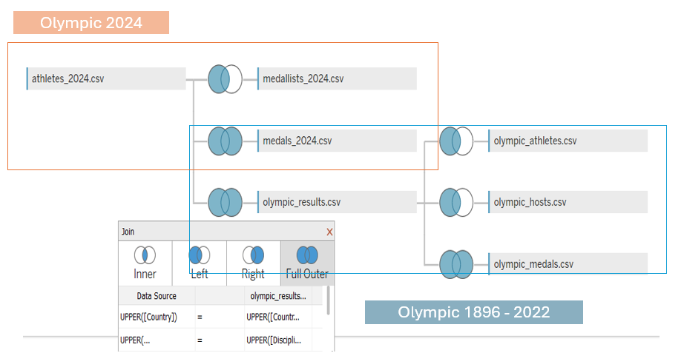

Figure 1. Joining Different Datasets